**Symbiont coexistence is common in mutualisms because of negative physiological feedback in preferential allocation and resource partitioning**

# Authors: Shyamolina Ghosh1, Daniel C. Reuman2, and James D. Bever3

# Authors Affiliations:

1Department of Ecology and Evolutionary Biology and Kansas Biological Survey, The University of Kansas, 1200 Sunnyside Avenue, Lawrence, KS, 66045, USA

2Department of Ecology and Evolutionary Biology and Kansas Biological Survey, University of Kansas, Lawrence, KS, 66047, USA; Laboratory of Populations, Rockefeller University, 1230 York Ave, New York, NY, 10065, USA

3Department of Ecology and Evolutionary Biology, The University of Kansas, 1200 Sunnyside Avenue, Lawrence, KS, 66045, USA

**Corresponding Author:** James D. Bever; Department of Ecology and Evolutionary Biology, The University of Kansas, 1200 Sunnyside Avenue, Lawrence, KS, 66045, USA; [jbever@ku.edu](mailto:jbever@ku.edu)

Short Title: Preferential Allocation and Symbiont Competition

**Abstract**

Simple arguments on stability of mutualism predict coexistence of symbionts of varying quality should be rare, yet diverse symbionts are commonly observed within roots of individual plants. We explore this paradox by evaluating the dynamics generated by symbiont competition for plant resources and plant preferential allocation to the most beneficial symbiont using a series of differential equations representing the densities of mutualistic and non-mutualistic symbionts and the level of preferentially allocated and non-preferentially allocated resources for which the symbionts compete. We find that plant preferential allocation and costs of mutualism will generate resource specialization that makes coexistence of beneficial and non-beneficial symbionts possible, and that coexistence becomes likely due to negative physiological feedback in plant preferential allocation. We find that biologically realistic models of plant physiology and symbiont competition predict that that coexistence of beneficial and non-beneficial symbionts should be common and that mutualistic density and relative abundance should increase in proportion to the needs of its host.

**Keywords**: preferential allocation, resource competition, species coexistence.

**Introduction**

Mutualisms are a remarkably common interaction, particularly between plants and symbionts. However, simple arguments suggest that the persistence and stability of mutualisms in the face of demonstrable costs is problematic. If plants reward symbionts indiscriminately and there is a cost to the symbiont for being mutualistic, then non-mutualist fitness will be greater than mutualist fitness and mutualism should decline. Recent demonstration of host preferential allocation to, and sanctions of, symbionts (Bever et al. 2009; Jandér and Herre 2010; Ji and Bever 2015; Kiers et al. 2011) have offered a resolution to this problem as preferential allocation can prevent the spread of cheating symbionts. With preferential allocation, the benefit available to the non-mutualist is reduced by fidelity of investment and mutualist fitness can exceed non-mutualist fitness when benefit weighed by fidelity is greater than the cost. This simple model of preferential allocation, however, identifies a second apparent paradox, as preferential allocation results in either all mutualists or all cheaters, but never local coexistence. Therefore, the forces that stabilize horizontally-acquired mutualisms over evolutionary timescales should eliminate variability in symbiont quality (Heath and Stinchcombe 2014). Why then, do mutualists of varying quality commonly coexist?

Currently, there are several solutions to this apparent paradox. Environmental variability may slow the rate of exclusion and maintain variation in mutualist quality (Moeller and Neubert 2016). A cost to the host of preferential allocation may generate negative community feedback, thereby leading to coexistence of beneficial and non-beneficial symbionts (Steidinger and Bever 2014). These two mechanisms will generate spatial heterogeneity in symbiont quality, thereby leading to coexistence. Several mechanisms have been proposed to explain the persistence of variation in mutualist quality within host in a static environment. Joint dynamics of host recognition and host sanctions against ineffective partners can allow the persistence of variation in symbiont quality (Yoder and Tiffin 2017). Mixed colonization of modules (e.g., rhizobia nodules or figs) permits coexistence of beneficial and non-beneficial symbionts in face of host discrimination (Steidinger and Bever 2016) and this framework has been shown to predict patterns of fig wasp dynamics (Jandér and Steidinger 2017).

For promiscuous nutritional mutualisms, which include the most common and consequential of plant-symbiont interactions such as mycorrhizae and N-fixation, variation in symbiont quality can persist within host roots of a single host (Bever 2002; Bever et al. 2009; Hart et al. 2013). Negative physiological feedback in the host for allocation to nutritional symbionts, as has been demonstrated for plant interactions with mycorrhizal fungi (Ji and Bever 2015; Zheng et al. 2015), can allow beneficial and non-beneficial symbionts to coexist and this mechanism predicts patterns of efficiency of mutualism across environmental gradients (Bever 2015). This mechanism allows that the host associates promiscuously with symbionts of varying quality and subsequently allocates preferentially to the most effective symbiont. This sequence allows for a second mechanisms of coexistence via resource partitioning, as non-beneficial symbionts could specialize on the plants initial investment in the association and beneficial symbionts capitalizes on plants preferential allocation to the most effective mutualist (Christian and Bever 2018). While the long-term dynamics of the symbiosis will then depend upon the joint operation of negative physiological feedback and symbiont resource competition, this dynamic has not been explored.

We present and analyze a general model that incorporates host preferential allocation toward the mutualist in proportion to its resource need (generating negative physiological feedback) and symbiont resource competition. We show that coexistence of beneficial and non-beneficial symbionts will be commonplace given expected costs. We then use this modeling framework to predict environmental patterns of the efficiency of nutritional mutualisms. While the model is general, we develop it in the context of arbuscular mycorrhizae, the most common plant nutritional mutualism. Construction of models governing efficiency of the mycorrhizal mutualism is of particular interest as this mutualism can have large impacts on terrestrial ecosystem function and sustainable agriculture through the modulation plant phosphorus uptake and mediation of carbon sink in soil.

**The Model**

In comparison to previous work (Bever 2015; Christian and Bever 2018), we present a more complete representation of plant-mycorrhizal community dynamics resulting from the interdependence of four state variables, namely, plant’s preferentially allocated carbon *(Ca)* to the mutualist, plant’s construction carbon *(Cc)* and the densities of two symbionts (mutualist *(M)* and non-mutualist *(N)*). Plants initially invest carbon *(Cc)* for the construction of symbiosis structure to the two types of symbionts promiscuously, as it cannot recognize the beneficial symbionts until trading commences. Plants then preferentially allocate their resources *(Ca)* to the mutualistic symbiont in exchange for phosphorus. As in Bever (2015), the accuracy of preferential carbon-allocation is represented by the fidelity *(f)* of preferential allocation. Fidelity depends on the spatial structure of the symbionts in the roots, the morphology and modularity of association, and the physiological potential of plants to allocate resources preferentially to mutualists even in absence of spatial structures. Fidelity has a range from 0 to 1, where *f = 0* means plants do not allocate preferentially to any specific symbiont at all and *f = 1* means plants allocate carbon to mutualist only. Both symbionts compete with each other to exploit the resources and mutualists have to pay a cost *(s)* due to mutualism which can reduce its maximum growth rate.

From our model as represented by Equations (1 - 4), we have derived the condition for co-existence of both symbionts and got the parameter range for fidelity *(f)* for a given cost *(s)*. The model is represented as follows;

| $$\frac{{dC}_{a}}{dt}=1-P_{s}-C_{a}F\left(M,N\right);F\left(M,N\right)=u\left[\frac{M}{K_{c}+M}\right]\left[\frac{M/{\left(M+N\right)}}{1-f+f\left[M/{\left(M+N\right)}\right]}\right]$$ | (1) |
| --- | --- |

|  | (2) |
| --- | --- |

|  | (3) |
| --- | --- |

|  | (4) |
| --- | --- |

All the terms and parameters are described in Table 1. Equation (1) represents the rate of change of allocated carbon which decreases with increasing phosphorous availability *(Ps)* in the soil. As colonization of plant roots by mutualists increases, plants receive more P per allocated carbon and this increase in efficiency results in plants needing to allocate less carbon to mycorrhizae (i.e. negative physiological feedback). We assume that the efficiency of P return, *F(M,N)* in Equation (1), is a saturating function of the density and proportion of mutualists, as shown in Figure 1 *(A)*. While the per capita growth rate of mutualist and non-mutualist decreases with same death rate (d), their growth rate is affected differently by costs and preferential allocation as represented in Equation (2) and Equation (3). Though fidelity *(f)* gives the advantage to the mutualist in access to allocated carbon, it has to pay an energetic cost *(s)* which decreases its growth rate on accessed carbon. Equation (4) demonstrates a constant supply rate *(Cc0)* for construction carbon, consistent with continual growth of a root system. The available construction carbon *(Cc)* is depleted as the roots are colonized by symbionts, as represented by a linear function of the product of total symbiont-density and the density of construction carbon itself.

By setting equation (1) and (4) equal to zero, we can get equilibrium values for allocated carbon () and construction carbon () as follows;

| | (5) |
| --- | --- |
| | (6) |

For finite equilibrium values of mutualist and non-mutualist (i.e., when), we set both equation (2) and (3) equal to zero and get the following two equations for mutualist and non-mutualist, respectively;

| | (7) |
| --- | --- |

|  | (8) |
| --- | --- |

Equation (7) indicates zero net growth isocline (ZNGI) for mutualist (so are subscripted with *M*) as a straight line with slope of -1 (see solid line in Figure 1 *(B)*) and equal intercepts on allocated carbon and construction carbon axes as *CaM*=CcM* =*  . Equation (8) represents the ZNGI (see dashed line in Figure 1 *(B)*) for non-mutualist (so $\hat{C_{c}}$ are subscripted with *N*) with a much steeper slope of *-1/(1-f)* as *0 <f <1*. The ZNGI for non-mutualist has unequal intercepts on their respective axes as *CaN\**= *CcN*/(1-f)= $\frac{K_{N}d}{\left(b_{max}-d\right)\left(1-f\right)}$*  . Christian and Bever (2018) identified that coexistence of mutualist and non-mutualist is possible if these two isoclines intersect for a set of positive finite values *(Ca*, *Cc)* depending on rates of supply of carbon resources*.* Here, we find that with negative physiological feedback adjusting the supply of allocated carbon, the mutualist and non-mutualist always co-exist for positive intersection of the carbon resource isoclines. We represent the condition for co-existence of both symbionts as follows;

| | (9) |
| --- | --- |

We can express the permissible range of fidelity *(f)* for co-existence of both symbionts as *fmin < f < fmax*, where *fmin* has the following generalized form;

| $$f_{min}=1-\left[\frac{K_{N}\left\{b_{max}\left(1-s\right)-d\right\}}{K_{M}\left(b_{max}-d\right)}\right]$$ | (10) |
| --- | --- |

If mutualist and non-mutualist had equal half-saturation constant *(KM = KN)* then minimum fidelity required to initiate co-existence of both symbionts would be $f_{min}=\frac{sb_{max}}{\left(b_{max}-d\right)}$ (Christian and Bever 2018). To get the higher limit of fidelity *fmax*, we have to ensure that equilibrium values for both symbionts should have positive finite values. The condition satisfies this scenario (for details see appendix A1) where is the equilibrium solution for mutualist.

We illustrate and confirm the potential dynamics using three different cases for different possible combination of fidelity *(f)* and *Cc0.* We solved numerically Equations (1) to (4) by classical 4th order Runge-Kutta method with time increment Δ*t = 0.01* and initial values for *(Ca, Cc, M, N)t=0* *= (0.5, 0.5, 1.0,1.0).* We set parameters *u = 0.4, bmax = 0.8, d = 0.5, s = 0.1, g = 0.2, Kc = 5* throughout our study. To understand how the equilibrium values for all four variables vary with fidelity *(f)* and phosphorous availability in soil (*Ps*), please see appendix A1.

**Results**

For different combinations of fidelity of plant investment *(f)* and construction carbon supply rates *(Cc0)*, we demonstrated symbionts could show different dynamics. For *f = 0.2* and *Cc0 = 5*, mutualist and non-mutualist ZNGI did not intersect (see Figure A1 *(A)*) violating the condition for coexistence (Equation 9), therefore destabilizing the system indicated by the numerical divergence in Figure A1 *(B)* and *(C).* Even if for very high supply of *Cc0*, stable coexistence is not possible for *f = 0.2*.

For relatively higher fidelity (*f* *= 0.3)*, two ZNGI for mutualist and non-mutualist intersect at positive phase-space of allocated and construction carbon (Figure 2A) indicating that both symbionts can co-exist. We found that the allocated and construction carbon concentrations reached the equilibrium state determined by the crossing of the isoclines regardless of the construction carbon supply rates *Cc0* (Figure 2B with *Cc0 =0.5* and Figure 2D with *Cc0 =5*). While the mutualist and non-mutualist coexisted regardless of the construction carbon supply rates, the relative abundance varied with mutualist dominating over non-mutualists for lower supply rates of construction carbon, *Cc0,*  (Figure 2C),but with increasing *Cc0* non-mutualist attained greater proportion than mutualist (Figure 2E). This phenomenon could be explained from the fact that with larger input of *Cc0*, non-mutualists grew faster as they had an energetic-cost advantage over mutualists. Figure 2F shows the variation of ratios of equilibrium values of construction carbon over allocated carbon () and non-mutualist over mutualist () as we varied *Cc0.* Regardless of *Cc0*, the equilibrium resource carbon-ratio was constant and symbionts coexisted. Symbiont dominance, however, switched when *Cc0* crossed approximately *1.1,* with mutualists dominating at lower values of *Cc0.* Our numerical finding was consistent with the analytic-condition for co-existence (Equations (9)) as for *f = 0.3*, *1 < CaN* / CaM* (=1.047) < 1/ (1-f) (=1.428)* with *fmin ~ 0.267.* Though at equilibrium resource-carbon levels remain independent with soil-phosphorous availability *(Ps)* for a given fidelity *f=0.3* (Figure2G), symbionts showed opposite behavior (mutualist decreased and non-mutualist increased with growing *Ps*) resulting in gradual decrease in proportion of mutualist at equilibrium () (Figure 2H). With *Ps = 0.3*, both symbionts showed co-existence at equilibrium for a limited range of fidelity *(f)*. Co-existence started at *f ~ 0.27* but as *f > fmax (~0.84)* the non-mutualist became extinct from the system and the mutualist won (Figure 2I) and reached to *1*. Equilibrium point remains always stable with co-existence of both symbionts as ensured by the negative eigenvalue (Figure A2, Appendix A1). Figure 2 is shown with *KM = KN = 10*, but we also carried out our analysis with *KM ≠ KN* and got similar conclusion (see Figure A3).

**Discussion**

Counter to perceptions that maintenance of diversity in symbiont quality is a problem (Heath and Stinchcombe 2014), we identify that preferential allocation to the most efficient mutualist can counter cost of mutualism allowing persistence of mutualists, and that this dynamic will likely result in coexistence of mutualist and non-mutualist. Coexistence results from the interaction of the complementary forces of resource partitioning and negative physiological feedback. Resource partitioning results from mutualists having greater access to preferentially allocated carbon (provided *f>0*) while non-mutualists have higher competitive ability on non-preferentially allocated carbon (provided *s>0*). Previous work identified a necessary condition for coexistence via resource partitioning (Christian and Bever 2018) under the standard assumptions of resource ratio theory. With negative physiological feedback governing plant allocation to the mutualist, supply rates change over time and act as an additional stabilizing force for coexistence (Bever 2015). We show that with negative physiological feedback the necessary conditions for coexistence are now also sufficient. Together, coexistence is more likely than predicted by either process alone (Bever 2015; Christian and Bever 2018).

Our results qualitatively differ from classic results from resource competition models and inferences from these models on the limiting similarity sufficient to allow coexistence of competitors (Grover and Grover 1997; MacArthur 1984; Tilman 1982). In earlier studies (MacArthur and Levins 1964; MacArthur 1984), researchers classically argued that species with similar niche, as defined by their zero growth isoclines, can only coexist when trade-offs cause crossing of these isoclines and when the resources are supplied within the narrow confines of their consumption vectors. In our system, the cost of mutualism and the fidelity of investment determine the trade-offs and crossing of the zero growth isoclines (Figures 2A, A3 A). The consumption vectors mapped onto this cross point, may circumscribe a narrow band of supply points (as shown in Figure 1B), yet coexistence is assured because negative physiological feedback moves the supply point of allocated carbon to within this range at equilibrium. Therefore, coexistence of mutualistic and non-mutualistic symbionts is more likely than might be expected from competing species in other systems.

Mutualisms have been likened to systems of cooperation (Bronstein 2001). Our system can be identified as a literal system of cooperation among mutualistic symbionts when fidelity of investment (*f*) is less than 1 because the mutualist is creating a public benefit (the allocated carbon). Simple evolutionary models have suggested that evolution of cooperation in systems of local dispersal (as would be true for symbionts) can be limited by competition with non-cooperators (Queller 1992; West et al. 2002). However, when the cooperative act increases local carrying capacity, as is the case for increased plant preferential allocation, then competition among symbionts is not a problem for the evolution of the cooperative trait (Platt and Bever 2009). We demonstrate that a more complete model of resource competition yields a high likelihood of persistence of the cooperative trait and coexistence with the non-cooperative trait.

*Relevance of model results to plant-mycorrhizal dynamics:*

Given their role in modulating plant nutrition, mycorrhizal fungal dynamics are critical to terrestrial carbon dynamics and validated models are necessary to predict these terrestrial response to anthropogenic perturbations. Our model represents an advance in this direction, as we build on basic aspects of the plant-mycorrhizal fungal biology that are capable of governing the efficiency of the mycorrhizal mutualism in the face of competition from non-beneficial symbionts (cheaters). Our model includes the energetic costs of P delivery to the fungus as a dynamic variable, in contrast to other formulations (Lu and Hedin 2019). The negative physiological feedback embedded within the model generates qualitative predictions on the efficiency of the mycorrhizal mutualism that are consistent with empirical patterns. As predicted by the model, the mycorrhizal communities become less mutualistic with increasing soil resources (Boerner 1990; Corkidi et al. 2002; Johnson 1993; Louis and Lim 1988) and more mutualistic with increasing levels of aboveground resource (Klironomos et al. 2005).

*Summary*

Counter to inference from simple models of preferential allocation and evolution of cooperation, we find that beneficial and non-beneficial (i.e. cheater) symbionts are likely to coexist. Our explicit model of symbiont competition for construction and preferentially-allocated carbon shows that beneficial and non-beneficial symbionts are likely to partition preferentially-allocated and construction carbon and that negative physiological feedback in the plant host regulates the supply rate of preferentially allocated carbon to maximize the likelihood of symbiont coexistence. Our model forms a foundation for heuristic understanding and predicting the efficiency of this ecologically critical mutualism.

**Acknowledgements**

SG and DCR are supported by a grant from the James S McDonnell Foundation and grant 1714195 from the National Science Foundation. JB acknowledges support from NSF grants DEB 1556664, DEB 1738041 and OIA 1656006.

**Tables**

Table 1: Description of model terms.

|  |  |
| --- | --- |
| Model Term | Definition |
| *Ca* | Density of allocated carbon that is discriminately and preferentially allocated to mutualists |
| *Cc* | Density of construction carbon that is allocated indiscriminately to symbionts to construct the site of symbiosis |
| *M* | Density of mutualist symbiont |
| *N* | Density of non-mutualist symbiont |
| *F(M,N)* | Function representing phosphorous uptake by both symbionts |
| *Ps* | Phosphorus availability in the soil |
| *u* | Phosphorous uptake per unit of preferentially allocated carbon received by mutualists |
| *f* | Fidelity of plant allocation to mutualist symbionts which has a range *(fmin , fmax)* |
| *s* | Cost of mutualism *(s >0)* |
| *bmax* | Maximum growth rate of symbionts |
| *d* | Constant death rate *(d < bmax)* |
| *Kc* | Half-saturation constant for allocated carbon |
| *KM* | Half-saturation constant for mutualist symbiont |
| *KN* | Half-saturation constant for non-mutualist symbiont |
| *g* | Rate at which construction carbon is allocated to both symbionts |
| *Cc0* | Source density of construction carbon stored in the plant |

**Figures**

B  
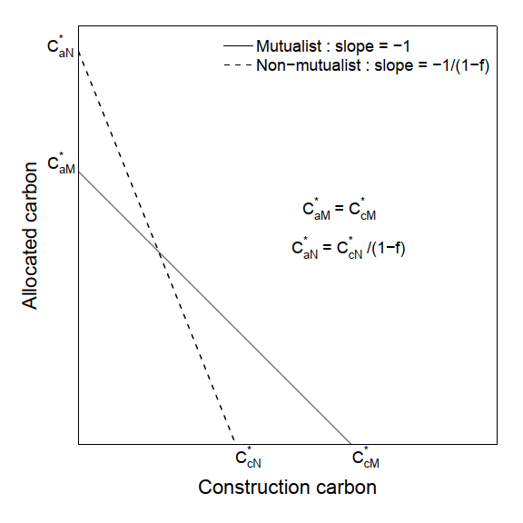

A  
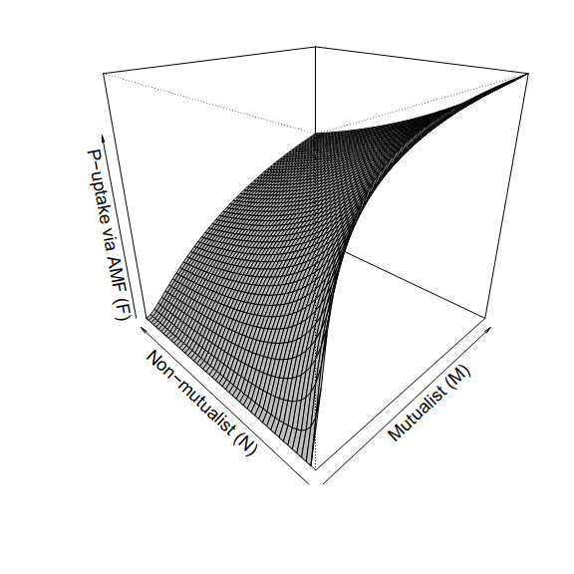

Figure 1: (A) P-uptake via mycorrhizal fungi *F(M,N)* as a function of densities of mutualists (M) and non-mutualist (N). M and N vary over range (0,100), parameters used: *f=0.3*, *u=0.4*, *Kc=5*.(B) Schematic diagram depicting the condition for stable co-existence of both symbionts.

Figure 2: For equal growth rate of both symbionts with *KM = KN = 10,* fidelity *f = 0.3*: (A) Zero net growth isoclines (ZNGI) for both symbionts intersect at a common point which indicates stable co-existence of mutualist and non-mutualist. Other parameters include *Ps = 0.3, u = 0.4, bmax = 0.8, d = 0.5, s = 0.1, g = 0.2, Kc = 5*. Two trajectories in the resource carbons’ phase space initiated at (0.5, 0.5) reached to that common point for *Cc0* *= 0.5* and *5*. (B) Numerical solutions of Equation (1) and (4): dynamics of allocated carbon (*Ca*) and construction carbon (*Cc*) respectively against time for *Cc0* *= 0.5*. (C) Numerical solutions of Equation (2) and (3): dynamics of mutualist (*M*) and non-mutualist (*N*) against time for *Cc0* *= 0.5*. (D - E) same as described for (B - C) but with *Cc0 = 5.* (F) Variation of equilibrium values of () and () against *Cc0* : construction carbon remained always lower than allocated carbon (green solid line below black dotted line at 1) as it is consumed by both symbionts, similarly with increasing greater storage of source construction carbon-density (*Cc0*) in the plant, non-mutualist dominated over mutualist in co-existing population. With *Cc0 = 5* and keeping other parameters fixed as mentioned earlier(G) analytical solution for equilibrium values (see Appendix A1) of allocated and construction carbon () remains at a fixed level when we vary phosphorous availability in soil (*Ps*). (H) Equilibrium value for mutualist () decreases as plant can avail phosphorous directly from soil and so does not depend upon the symbionts much, whereas equilibrium value for non-mutualist () increases with soil-phosphorous as it gets same level of resources as that of mutualist without paying any cost of mutualism (*s*). As a result proportion of mutualism at equilibrium () decreases with soil-phosphorous level. (I) With *Ps = 0.3*, *Cc0 = 5* and other parameters as mentioned earlier, equilibrium value for mutualist () initially decreases but then increases as fidelity *(f)* approaches its maximum value *fmax (~0.84)*, so approaches to 1 as becomes rare from the system. The equilibrium remains always stable for all possible parameter range whenever both symbionts coexist (see Figure *A2*).

A  
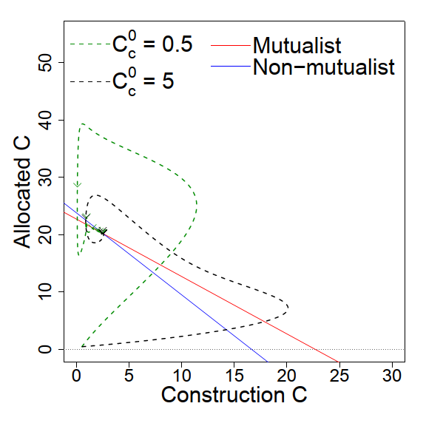

I  
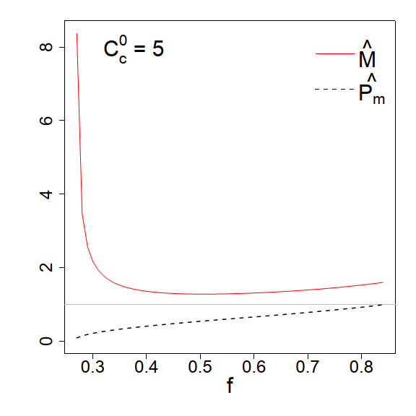

H  
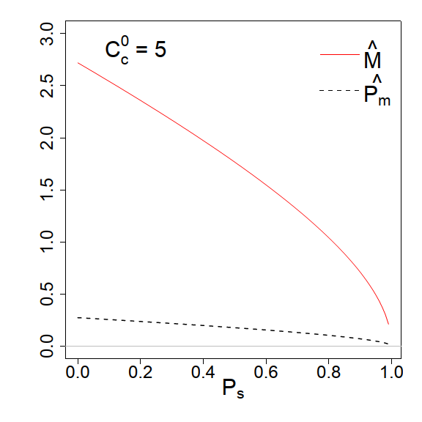

G  
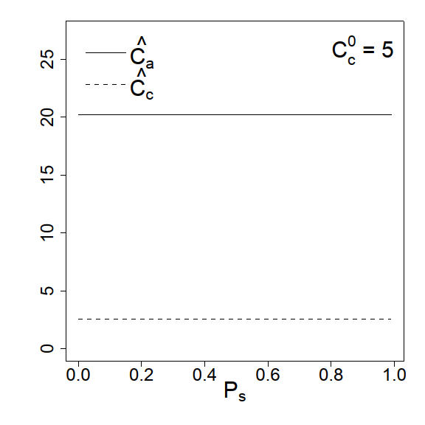

F  
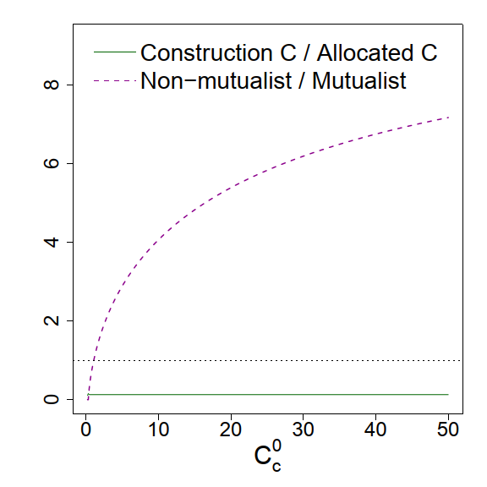

E  
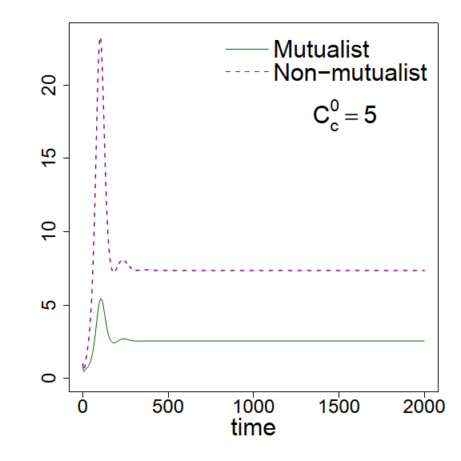

D  
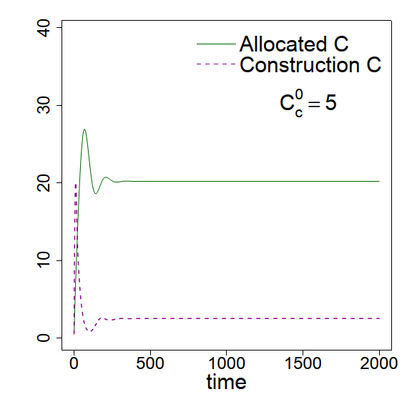

C  
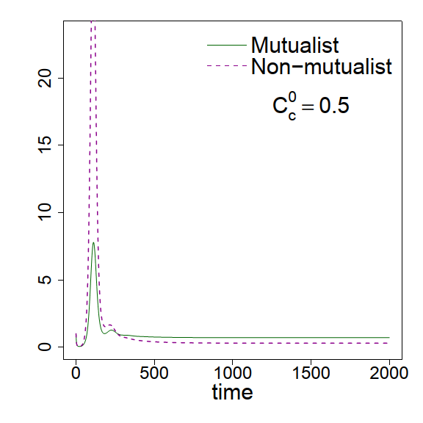

B  
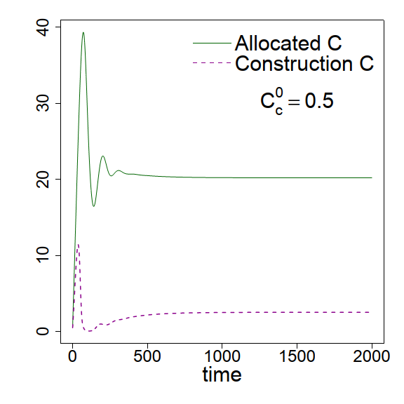

**Appendix:**

**A1: Equilibrium solution for allocated carbon, construction carbon and both symbionts**

Solving Equations (5) to (8), we get equilibrium solutions for allocated carbon (), construction carbon (), mutualist () and non-mutualist () (given a finite phosphorous uptake per unit of preferentially allocated carbon received by mutualists (*u*)) as follows;

| Where, $$α_{1}=\frac{K_{M}duβ}{b_{max}\left(1-s\right)-d}-\frac{C_{c}^{0}u}{g}-βf\left(1-P_{s}\right)$$ $$α_{2}=-\left(1-P_{s}\right)K_{c}βf-β^{2}\left(1-f\right)\left(1-P_{s}\right)$$ $$α_{3}=-\left(1-P_{s}\right)\left(1-f\right)K_{c}β^{2}$$ $$β=\frac{{-fC_{c}^{0}}/{g\left(1-f\right)}}{d\left[\frac{K_{M}}{b_{max}\left(1-s\right)-d}-\frac{K_{N}}{\left(b_{max}-d\right)\left(1-f\right)}\right]}$$ |  |
| --- | --- |
|  |  |

This equilibrium solution is valid when both and $\hat{N}$ has some positive finite values, i.e., when they co-exist. Analytically this is guaranteed with. Information about the stability of equilibrium can be accessed by the eigenvalues (), where $τ$ and $Δ$ are the trace and determinant of the Jacobian matrix (*J*), respectively. Following Eqs. (1 - 4), one can construct the Jacobian (*J*);



We numerically tested with a wide range of all the parameters and found the equilibrium point remained always stable [*max () < 0*] whenever both mutualists and non-mutualists co-existed.

Figure A1: (A) For fidelity *f = 0.2*: Zero net growth isoclines (ZNGI) for both symbionts do not intersect no coexistence of both symbionts is possible (Equation 9 is not satisfied, *CaN* / CaM\** < *1*). Trajectories in the resource carbons’ phase space initiated at (0.5, 0.5) diverged for *Cc0* *= 5.* (B) Numerical solution of Equation (1) and (4): dynamics of allocated carbon (*Ca*) and construction carbon (*Cc*) against time for *Cc0* *= 5*. (C) Numerical solution of Equation (2) and (3): dynamics of mutualist (*M*) and non-mutualist (*N*) against time for *Cc0* *= 5*. The system showed unrealistic numerical solution as construction carbon (*Cc*) become negative after a short time. Fidelity was also not sufficient to compensate mutualist’s need for energetic cost (*s = 0.1*), so mutualist became rare in that system whereas non-mutualist grew abundantly. Non-mutualist only uptake resources from the plant without adding any benefit, so the system collapsed. Other parameters used as *KM = KN =10.0, Ps = 0.3, u = 0.4, bmax = 0.8, d = 0.5, s = 0.1, g = 0.2, Kc = 5.*

A  
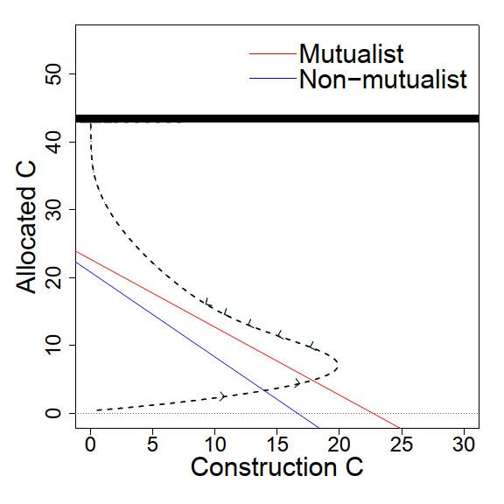

B  
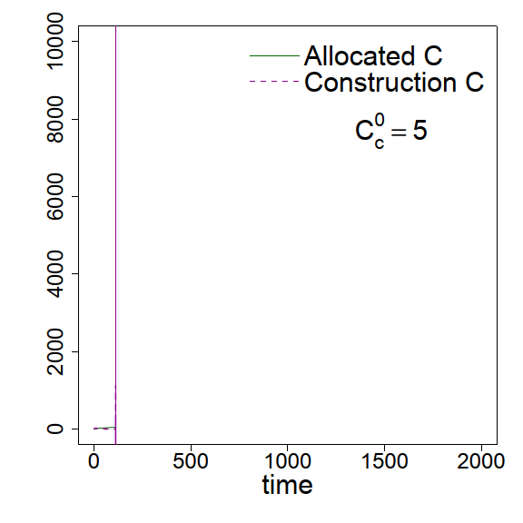

C  
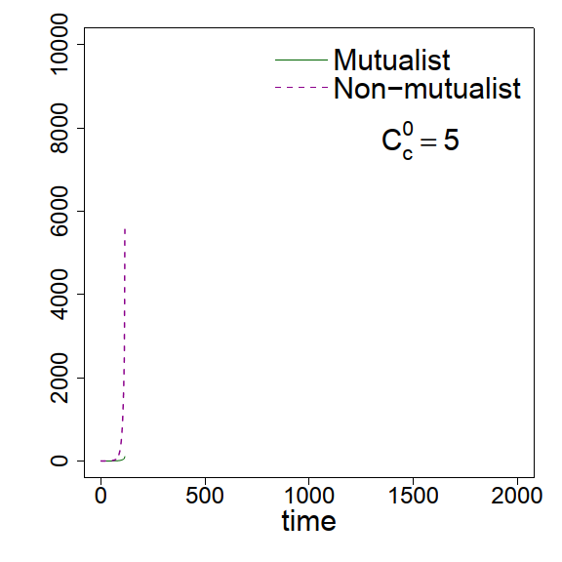

Figure A2: Stability of equilibrium in (A) and (B) is confirmed by the maximum eigenvalues which remain always negative with the parameter values we used for Fig. 2 (H) and (I), respectively.

B  
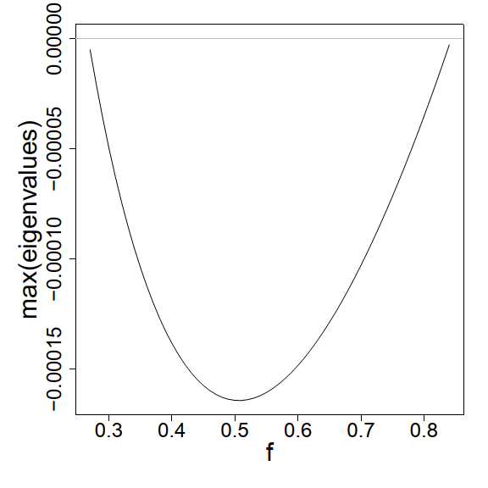

A  
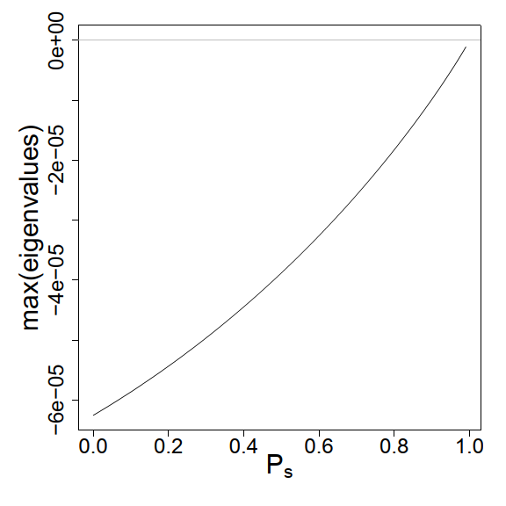

H  
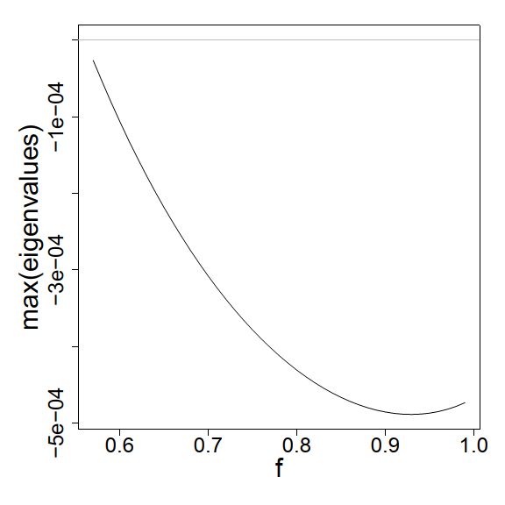

G  
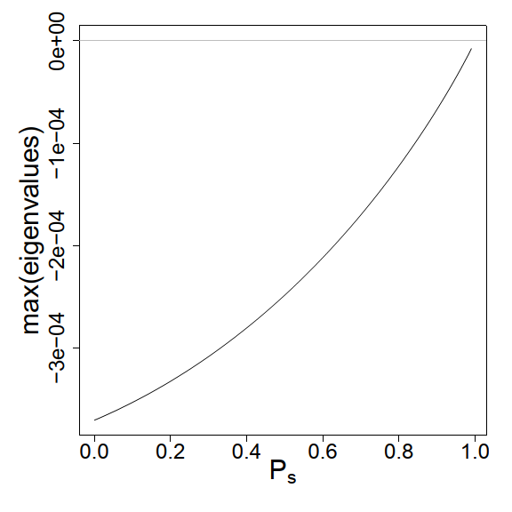

F  
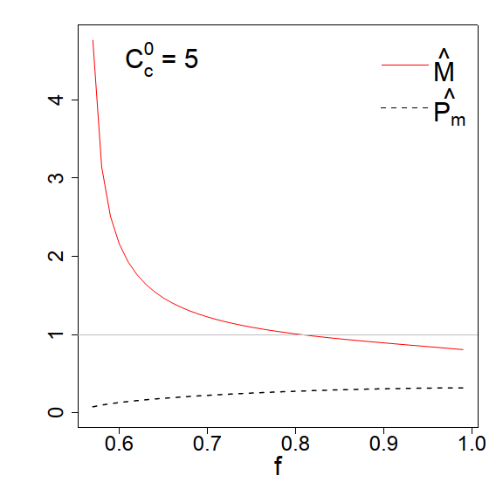

E  
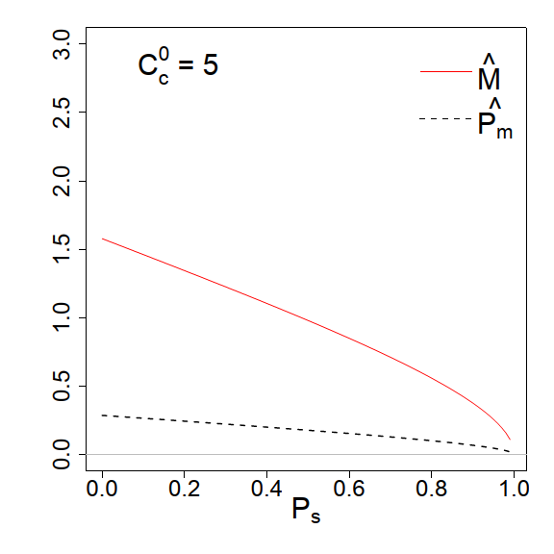

D  
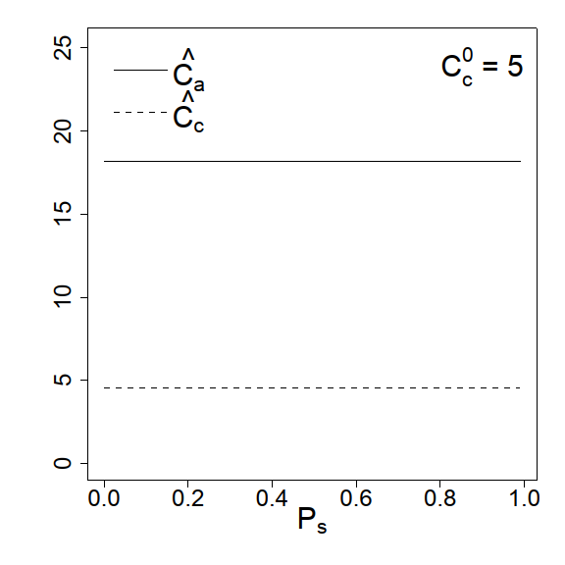

C  
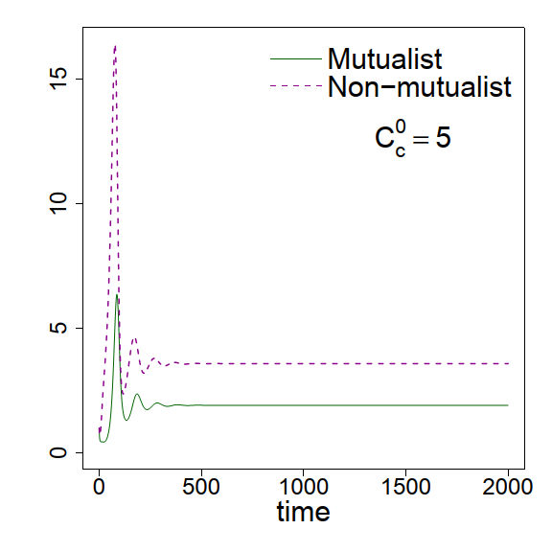

B  
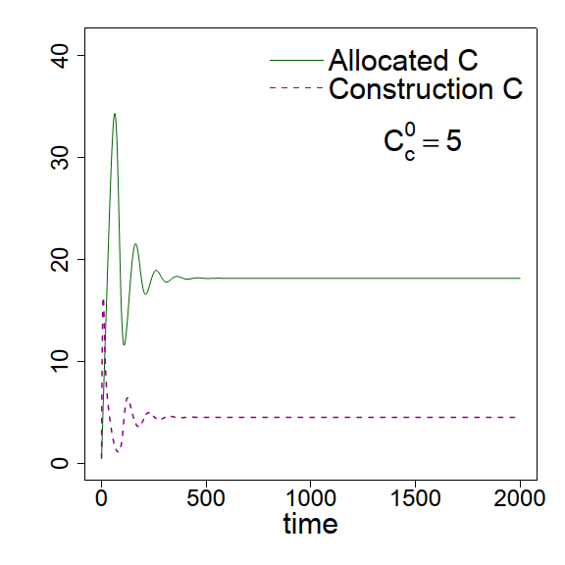

A  
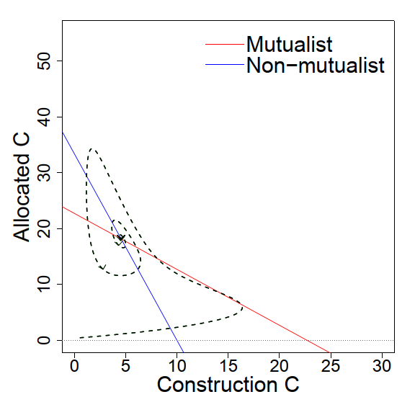

Figure A3: (A) For different growth rates of symbionts with parameters *KM =10.0, KN = 6.0, f = 0.7, Ps = 0.3, u = 0.4, bmax = 0.8, d = 0.5, s = 0.1, g = 0.2, Kc = 5*: Zero net growth isoclines (ZNGI) for both symbionts intersect at positive resource carbon’s phase space. Though non-mutualist has higher growth rate (as *KN < KM*), increased fidelity with minimum fidelity *fmin* *= 0.56* (compare with the *fmin* *= 0.26* of Fig. 2) added an advantage to the mutualist-abundance enabling it to co-exist with non-mutualist. Trajectory in the resource carbons’ phase space initiated at (0.5, 0.5) reached to two different equilibrium values for *Cc0* *= 5*. (B) Solution of Equation (1) and (4): dynamics of allocated carbon (*Ca*) and construction carbon (*Cc*) against time for *Cc0* *= 5*. (C) Solution of Equation (2) and (3): dynamics of mutualist (*M*) and non-mutualist (*N*) against time for *Cc0* *= 5*. (D - F) similar as described for Figure 2(G - I) but with default values *Cc0* *= 5, f = 0.7, Ps = 0.3.* (G - H)maximum eigenvalue remained always negative (indicating the equilibrium was always stable for co-existence of both symbionts) for whole range of soil phosphorous (*Ps*) and fidelity (*f*).

Bever, J. D. 2002. Negative feedback within a mutualism: host–specific growth of mycorrhizal fungi reduces plant benefit. Proceedings of the Royal Society of London. Series B: Biological Sciences 269:2595-2601.

Bever, J. D. 2015. Preferential allocation, physio-evolutionary feedbacks, and the stability and environmental patterns of mutualism between plants and their root symbionts. New Phytologist 205:1503-1514.

Bever, J. D., S. C. Richardson, B. M. Lawrence, J. Holmes, and M. Watson. 2009. Preferential allocation to beneficial symbiont with spatial structure maintains mycorrhizal mutualism. Ecology Letters 12:13-21.

Boerner, R. E. 1990. Role of mycorrhizal fungus origin in growth and nutrient uptake by Geranium robertianum. American Journal of Botany 77:483-489.

Bronstein, J. L. 2001. The exploitation of mutualisms. Ecology letters 4:277-287.

Christian, N., and J. D. Bever. 2018. Carbon allocation and competition maintain variation in plant root mutualisms. Ecology and evolution 8:5792-5800.

Corkidi, L., D. L. Rowland, N. C. Johnson, and E. B. Allen. 2002. Nitrogen fertilization alters the functioning of arbuscular mycorrhizas at two semiarid grasslands. Plant and Soil 240:299-310.

Hart, M. M., J. Forsythe, B. Oshowski, H. Bücking, J. Jansa, and E. T. Kiers. 2013. Hiding in a crowd—does diversity facilitate persistence of a low-quality fungal partner in the mycorrhizal symbiosis? Symbiosis 59:47-56.

Heath, K. D., and J. R. Stinchcombe. 2014. Explaining mutualism variation: a new evolutionary paradox? Evolution 68:309-317.

Jandér, K. C., and E. A. Herre. 2010. Host sanctions and pollinator cheating in the fig tree–fig wasp mutualism. Proceedings of the Royal Society of London B: Biological Sciences 277:1481-1488.

Jandér, K. C., and B. S. Steidinger. 2017. Why mutualist partners vary in quality: mutation–selection balance and incentives to cheat in the fig tree–fig wasp mutualism. Ecology letters 20:922-932.

Ji, B., and J. D. Bever. 2015. Plant preferential allocation and fungal reward decline with soil phosphorus enrichment: implications for evolution of the arbuscular mycorrhizal mutualism. Ecosphere In Press.

Johnson, N. C. 1993. Can fertilization of soil select less mutualistic mycorrhizae? Ecological applications 3:749-757.

Kiers, E. T., M. Duhamel, Y. Beesetty, J. A. Mensah, O. Franken, E. Verbruggen, C. R. Fellbaum et al. 2011. Reciprocal Rewards Stabilize Cooperation in the Mycorrhizal Symbiosis. Science 333:880-882.

Klironomos, J. N., M. F. Allen, M. C. Rillig, J. Piotrowski, S. Makvandi-Nejad, B. E. Wolfe, and J. R. Powell. 2005. Abrupt rise in atmospheric CO 2 overestimates community response in a model plant–soil system. Nature 433:621.

Louis, I., and G. Lim. 1988. Differential response in growth and mycorrhizal colonisation of soybean to inoculation with two isolates ofGlomus clarum in soils of different P availability. Plant and Soil 112:37-43.

Lu, M., and L. O. Hedin. 2019. Global plant–symbiont organization and emergence of biogeochemical cycles resolved by evolution-based trait modelling. Nature ecology & evolution 3:239.

MacArthur, R., and R. Levins. 1964. Competition, habitat selection, and character displacement in a patchy environment. Proceedings of the National Academy of Sciences of the United States of America 51:1207.

MacArthur, R. H. 1984, Geographical ecology: patterns in the distribution of species, Princeton University Press.

Moeller, H. V., and M. G. Neubert. 2016. Multiple friends with benefits: an optimal mutualist management strategy? The American Naturalist 187:E1-E12.

Platt, T. G., and J. D. Bever. 2009. Kin competition and the evolution of cooperation. Trends in ecology & evolution 24:370-377.

Queller, D. C. 1992. A general model for kin selection. Evolution 46:376-380.

Steidinger, B. S., and J. D. Bever. 2014. The Coexistence of Hosts with Different Abilities to Discriminate against Cheater Partners: An Evolutionary Game-Theory Approach. American Naturalist 183:762-770.

Steidinger, B. S., and J. D. Bever. 2016. Host discrimination in modular mutualisms: a theoretical framework for meta-populations of mutualists and exploiters. Proc. R. Soc. B 283:20152428.

West, S. A., I. Pen, and A. S. Griffin. 2002. Cooperation and competition between relatives. Science 296:72-75.

Yoder, J. B., and P. Tiffin. 2017. Sanctions, partner recognition, and variation in mutualism. The American Naturalist 190:491-505.

Zheng, C., B. Ji, J. Zhang, F. Zhang, and J. D. Bever. 2015. Shading decreases plant carbon preferential allocation towards the most beneficial mycorrhizal mutualist. New Phytologist 205:361-368.